Entry Form
NAME______________________________________ AGE_______
ADDRESS___________________________________________________________
PHONE___________________________________________
TAG NUMBER | LAMB OR GOAT | BORN AND BRED (YES or NO) | ENTRY FEE ($10 per Head) | LATE ENTRY FEE (Additional $10 per Head)

TOTAL FEES $

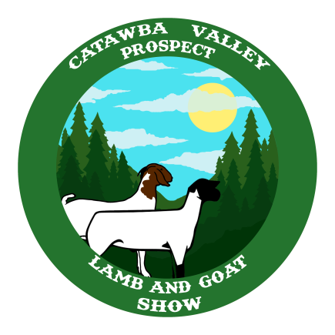
PLEASE MAKE CHECKS AND RETURN BY JUNE 7 TO:

CATAWBA VALLEY PROSPECT LAMB SHOW
CATAWBA COUNTY EXTENSION OFFICE
P.O. BOX 389
NEWTON, NC 28658

